|  |  |
| --- | --- |
| Single Page Application on Task manager  MEAN FSD 8 Hour Code Capsule | Abstract  The Task Manager solution should be a Single Page Application (SPA) to keep track of upcoming tasks, finished tasks and their respective priorities.  Developer  MEAN Full Stack Developer |

# Business-Requirement: An Overview

**The Task Manager Single Page Application** allows you to manage task and set their priorities in range of 0 to 30. Each task will have parent task (optional/another task can be made parent), start date and end date. Below are the features of Task Manager:

1. Add/Edit/View/Delete Task
2. You can make one task a parent of another task.
3. On view task screen:
   1. User can search task by task name, parent task, start date, end date and priority.
   2. User can edit task
   3. User can end the task once it is finished. Once ended, user cannot edit the task. User can only view the task once finished.
4. All search fields on view task screen are using auto-filter property of angularjs.

# Technical Spec –Solution Development Environment

## Front End Layer

|  |  |
| --- | --- |
| **Framework(s)/SDK/Libraries** | **Version** |
| AngularJS | 1.5 or above |
| Bootstrap | 3.0 or above |
| CSS | 3 |
| HTML | 5 |
| JavaScript | **1.8 or above** |
| JQuery | **1.3** |

## Middle Tier Layer

|  |  |  |
| --- | --- | --- |
| **Technology** | **Framework(s)/SDK/Libraries** | **Version** |
| MEAN Stack | Node.JS | 6.x (Latest: 6.11.4) |
| Express.JS | 4.16.1 |

## Database & Integration Layer

|  |  |  |
| --- | --- | --- |
| **Technology** | **Framework(s)/SDK/Libraries** | **Version** |
| MEAN Stack | MongoDB/MySQL |  |
| NoSQL |  |
| Mongoose.JS | 4.12.1 |

## Ancillary Layer

|  |  |  |
| --- | --- | --- |
| **Technology** | **Framework(s)/SDK/Libraries** | **Version** |
| Source Code Management Tool | GIT | 2.14.2 |
| Build Tool/MEAN Stack | Grunt/Gulp | 1.0.1/3.9.1 |
| Dependency Management Tool/MEAN Stack | NPM | 4.x |
| Testing Tool/MEAN Stack | Jasmine |  |

## Deployment & Infrastructure

|  |  |  |
| --- | --- | --- |
| **Technology** | **Framework(s)/SDK/Libraries** | **Version** |
| Docker | - |  |
| Apache HTTP (XAMPP) | - |  |
| Node | - |  |
| Dependency Management Tool | NPM |  |

## Editors

|  |  |
| --- | --- |
| **Name** | **Version** |
| Adobe Brackets |  |
| Sublime Text |  |
| Atom Editor |  |

# Wireframes

## Add Task

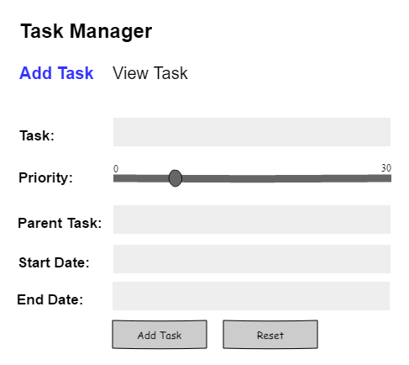

## View Task

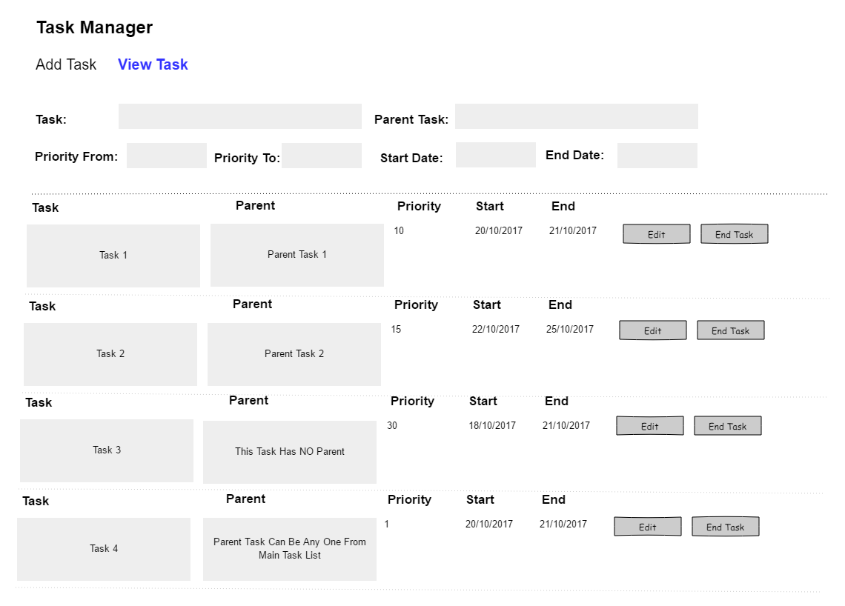

## Update Task

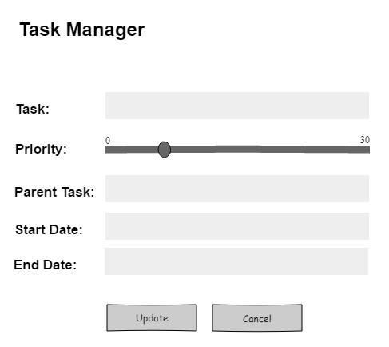

# Database Tables

|  |  |  |  |
| --- | --- | --- | --- |
| **Parent Task Table** |  | **Task Table** |  |
|  |  |  |  |
| Parent_ID |  | Task_ID |  |
| Parent_Task |  | Parent _ID |  |
|  |  | Task |  |
|  |  | Start_Date |  |
|  |  | End_Date |  |
|  |  | Priority |  |
|  |  | Finished |  |
|  |  |  |  |
|  |  |  |  |
|  |  |  |  |